Sign Up Genius – How To Guide

- Sign Up Genius is our web-based Serving In Worship Manager. If you already have an account, log in to view and sign up for current Serving in Worship opportunities.
- If you don't have an account, click this link or go to signupgenius.com to go directly to home page.
- In the upper right hand corner, find the magnifying glass and click on it. This will take you to the search page.

- In the lower left corner, find where it allows you to search by creator’s email and type in office@stthomasrichmond.org. It will ask you to complete an image challenge to ensure you are not a computer, then hit search.

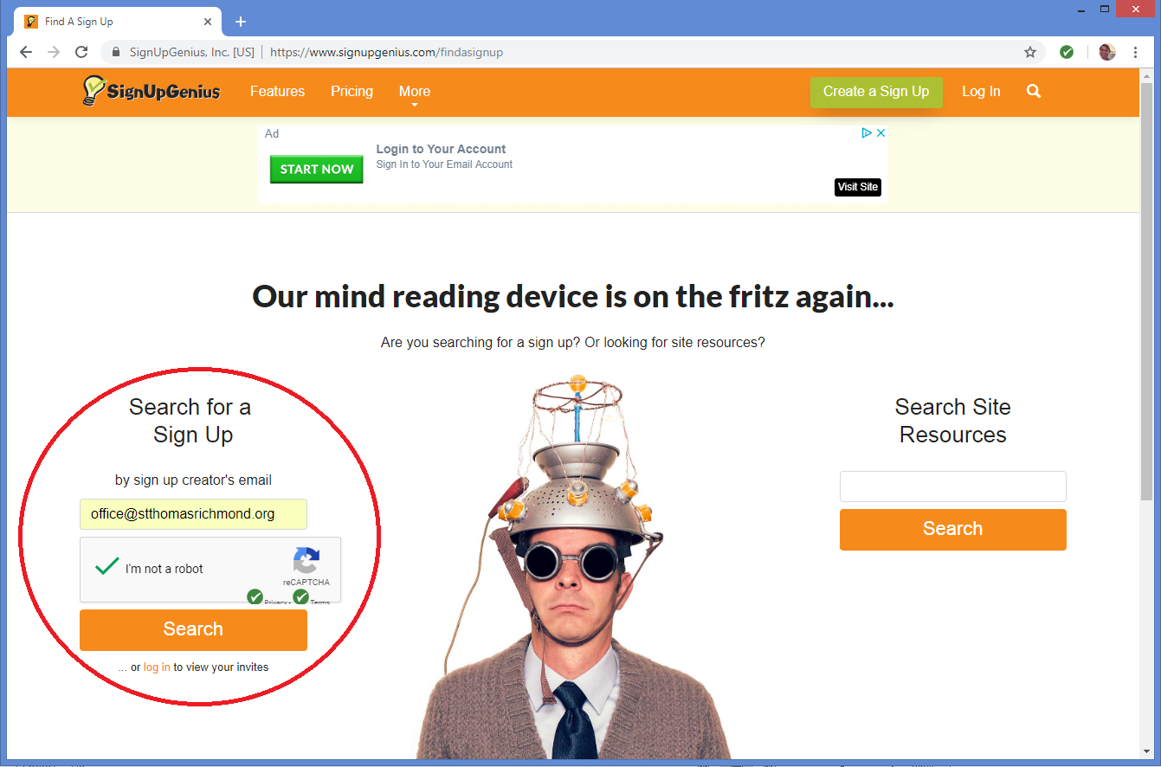

- This will bring you to St. Thomas’ Volunteer Page. Here you may select which Volunteer opportunity you’d like to explore. For this tutorial, we will select Serving in Worship.

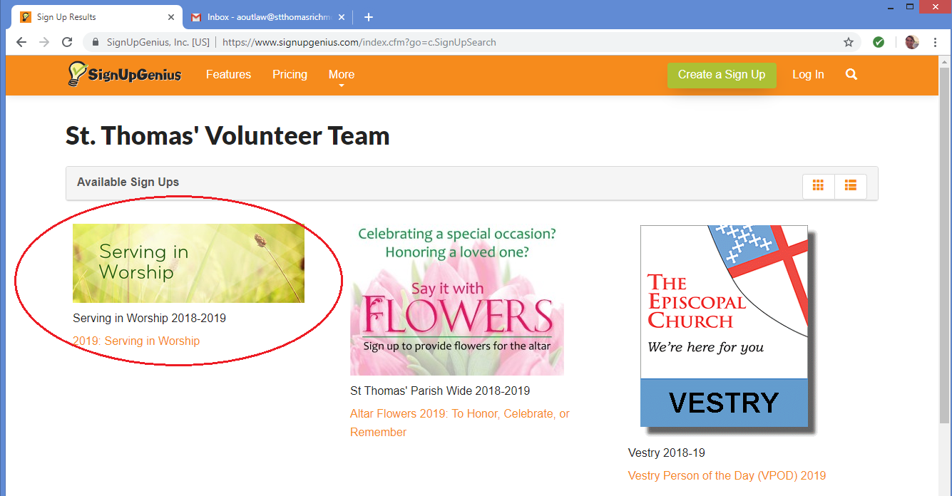

- Once you are on the page, scroll down to view a list of dates, times, and descriptions of what volunteer service is needed. If you are available and would like to serve, please select “Sign Up” in the box next to the description. You are successful if a black check mark appears in the box.
- You may then click the blue button at the very bottom of the website that states “Submit and Sign Up” to continue.

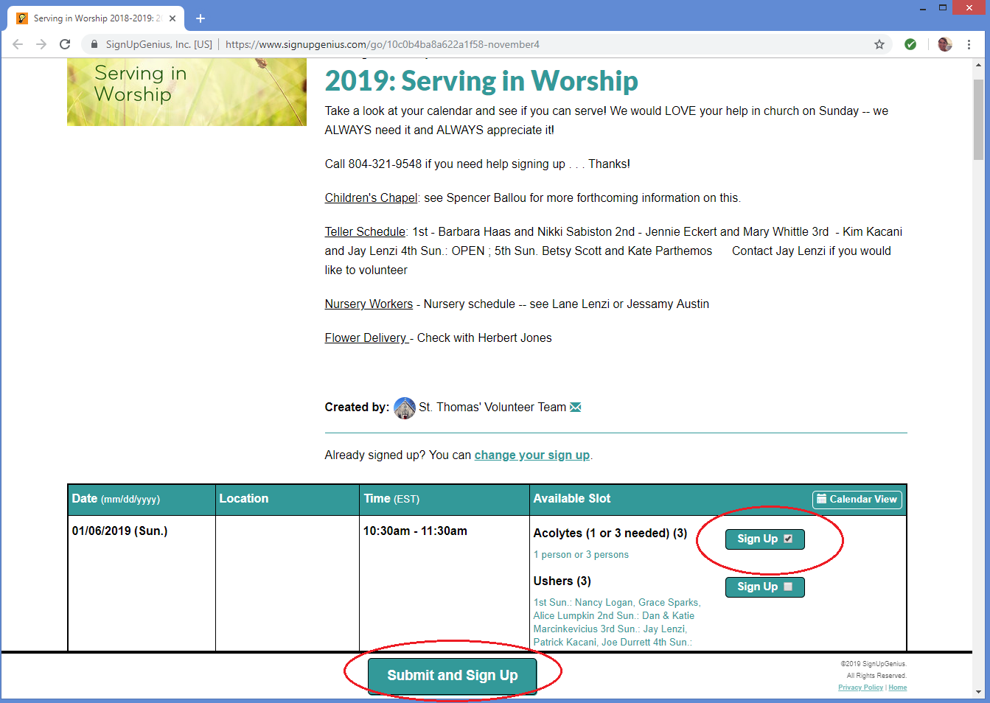

- Finally, this brings you to the page where you can fill in your information as well as confirm what you are signing up for. Please review the available slot and date to make sure you selected the correct opportunity.
- Fill in your name and your email address. This will allow us to remind you of your sign up and know who to expect in that role. To continue, click “Sign Up Now”.

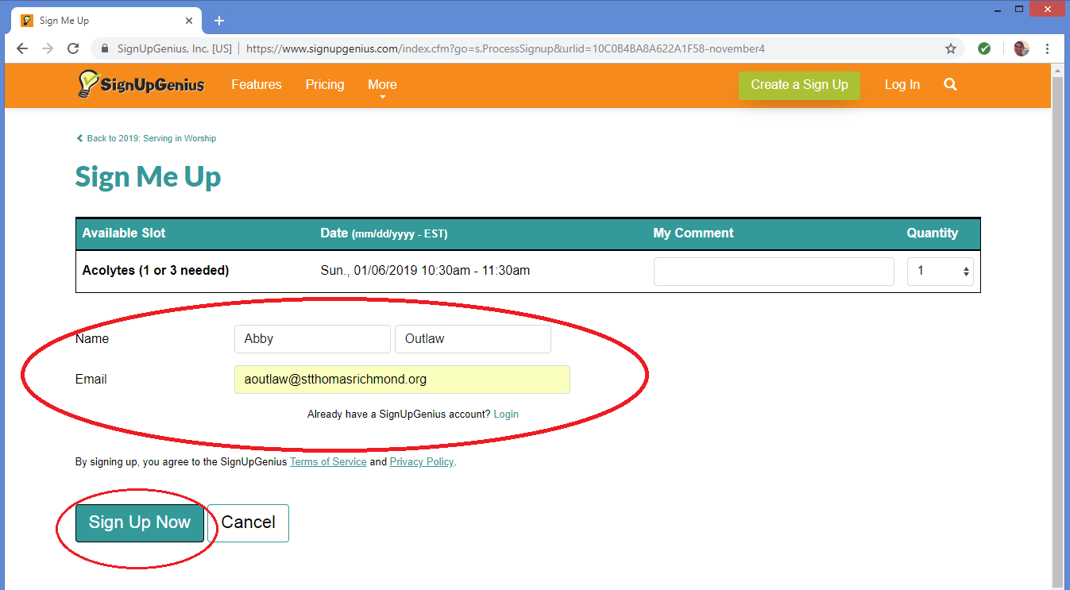

- After submitting, you will receive a confirmation page like the one below. You will also receive an email confirmation.
- If you need assistance during this process, please call the parish office at 804-321-9548 and we will be happy to help you sign up!

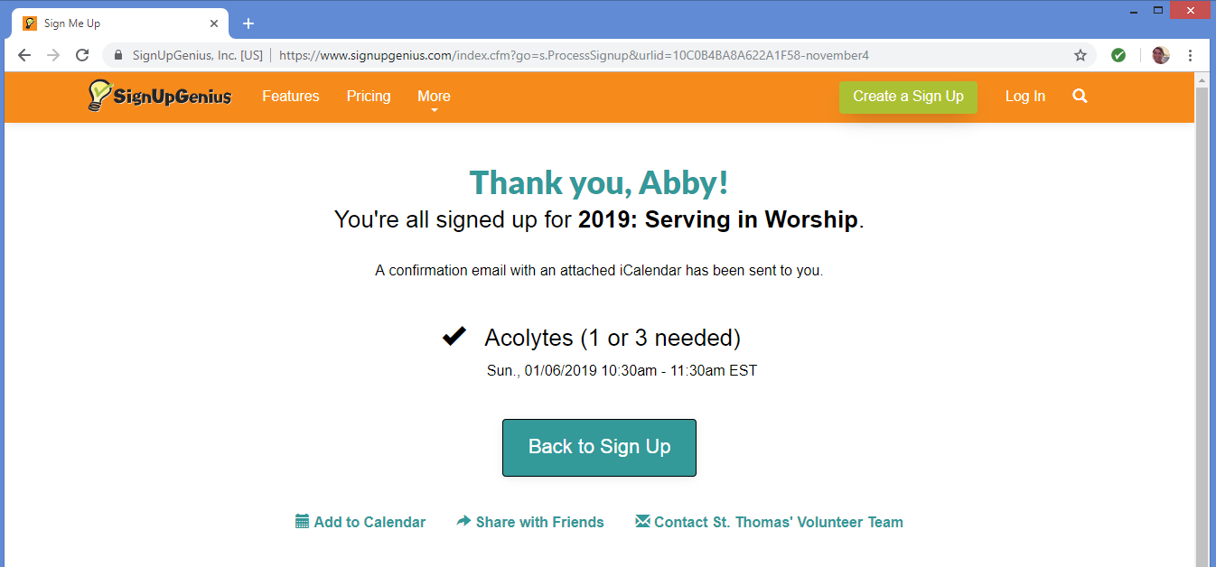

Thank you for volunteering to serve in worship, we appreciate all of your help!

